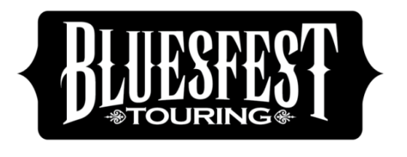

For all things Bluesfest Touring visit: bluesfesttouring.com.au
Find us on Facebook - Bluesfest Touring Twitter: @bluesfestouring #bluesfesttouring

RHIANNON GIDDENS ANNOUNCED AS SPECIAL GUEST SUPPORT FOR
BONNIE RAITT IN SYDNEY

Bluesfest Touring is proud to announce that Grammy winner Rhiannon Giddens will take the stage before Bonnie Raitt in Sydney. She wowed audiences with her emotional range and dazzling vocal prowess at Bluesfest last year, with many calling her the best act at the festival. Rhiannon is the Grammy Award–winning lead singer of African-American folk interpreters Carolina Chocolate Drops, however she has now stepped out on her own, winning over audiences around the world, with “the fervor of a spiritual, the yips of a folk holler, and the sultry insinuation of the Blues” according to the New York Times.

Full support artist bio below.
Bonnie Raitt Proudly presented by PBS 106.7 FM, Eastside Radio and Beat & Brag

Bonnie Raitt
Supported by Rhiannon Giddens
State Theatre, Sydney NSW – Friday 7 April 2017

Rhiannon Giddens

The Grammy Award–winning lead singer of African-American folk interpreters Carolina Chocolate Drops, has stepped out on her own, winning over audiences around the world, with as the New York Times put it, “the fervor of a spiritual, the yips of a folk holler, and the sultry insinuation of the blues”.
On her solo debut Tomorrow Is My Turn, Giddens delivers striking renditions of Dolly Parton’s ‘Don’t Let It Trouble Your Mind’, & Hank Cochran’s ‘She’s Got You’, popularised by Patsy Cline. The album incorporates gospel, jazz, Blues, and Country, plus a hint of proto-Rock’n’Roll, and Giddens displays an emotional range to match her dazzling vocal prowess throughout.
Music legend T Bone Burnett says of Giddens. “It was clear the first time I heard her at rehearsal that Rhiannon is next in a long line of singers that includes Marian Anderson, Ethel Waters, Rosetta Tharp, Odetta, Mahalia Jackson, Nina Simone,” Burnett says. “We need that person in our culture. She is, in fact, that person in our culture.”
“What was on display tonight was the performance of an artist on the cusp of a true critical and commercial breakthrough with a voice that was regal, confident and, at every turn, breathtaking.”
-The Musical Box

“Giddens explores the frontiers of Americana on a solo debut of phenomenal vocal power, effortlessly jumping between gospel holler, tender folk song and lachrymose country ballad.” - The Guardian

